Group Assignment 3

October 16, 2020

Name: Felicity Harvard | NetId: fah78 | GitHub Username: FelicityHarvard

Name: Heather Bostick | NetId: heb329 | GitHub Username: Hbostick28

Name: Conner Chapin | NetId: cwc291 | GitHub Username: chapiiin

Name: Abby Glenn | NetId: ag2461 | GitHub Username: abbyg41

Link to GitHub Repository:<https://github.com/chapiiin/OSC>

* [You have to reverse engineer the code and create a UML Class Diagram that actually represents the code base (i.e., the descriptive architecture)] Compare / contrast prescriptive architecture (UML Class Diagram you created in Assignment 2) with actual descriptive architecture (the UML class diagram representing the actual codebase)

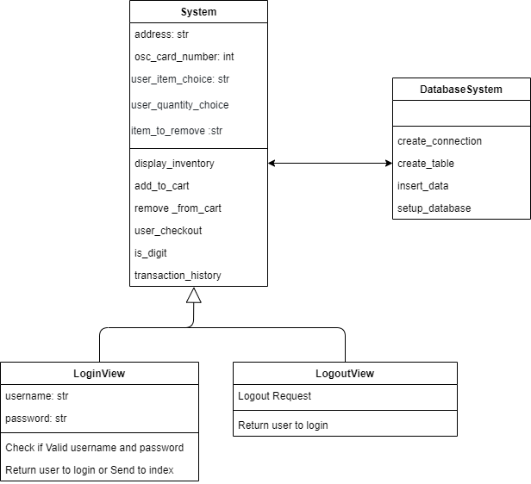

* + Discuss similarities and differences between the class diagrams (20 pts: 10 for similarities, 10 for differences)

Some differences between these class diagrams is that the reverse engineered class diagram is more condense, more items within individual classes, and the original class diagram has more spread out, contains more classes, and has less within the clases. Another difference is that the original diagram contains more variables as the reversed engineered one has less variables and more functions within the classes (such as add_to_cart, setup_database,ect..).

Some similarities is that both class diagrams contain similar functions. They also both work similarity just broken up in different ways. The classes in the reversed engineered diagram are in the original diagram. They both also have similar variables.

* + Why is the implementation different (5 pts)? What aspects of the implementation did the original prescriptive design not consider (clearly mention if you do not have such a case) (5 pts)? Why the changes were needed (clearly mention if you do not have such a case) (5 pts)?

The implementation is different because the original class diagram was made with no specific coding language and no past coding experience in mind. Some aspects of the implementation that the origningal prescopitce design did not consider was breakdown of the function and where the functions would go in the classes. Another aspect would be that the database was not depicted in detail in the original prescriptive. The changes were needed in order to create the software with our teams skills and knowledge. We also made these changes to make implantation more comfortable to our execution.

* + Include both prescriptive (class diagram from Assignment 2) and actual descriptive diagrams in report (35 pts: 10 pts for prescriptive, 25 pts for descriptive)

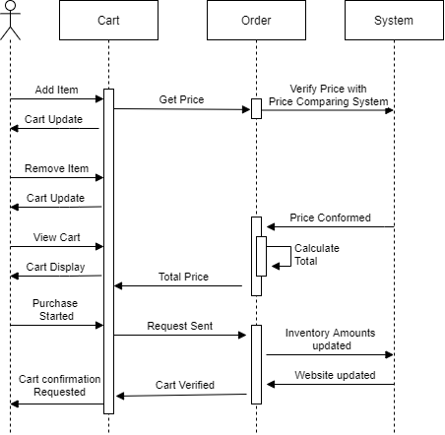

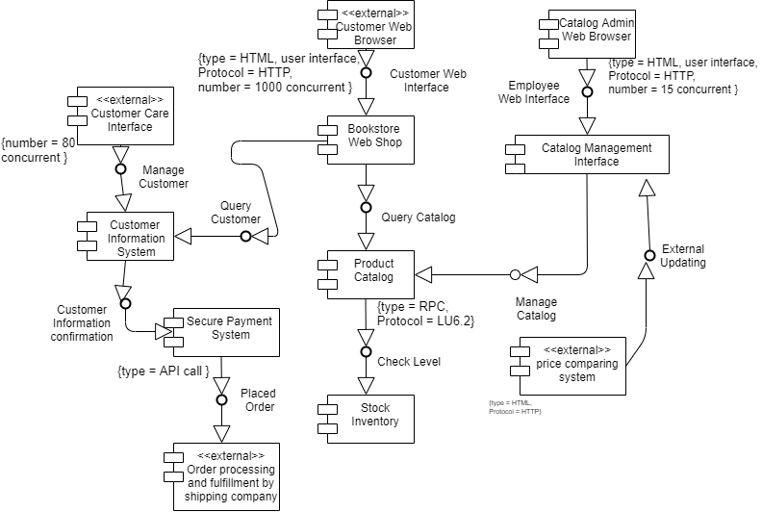

* Lessons learned (3+ paragraphs) 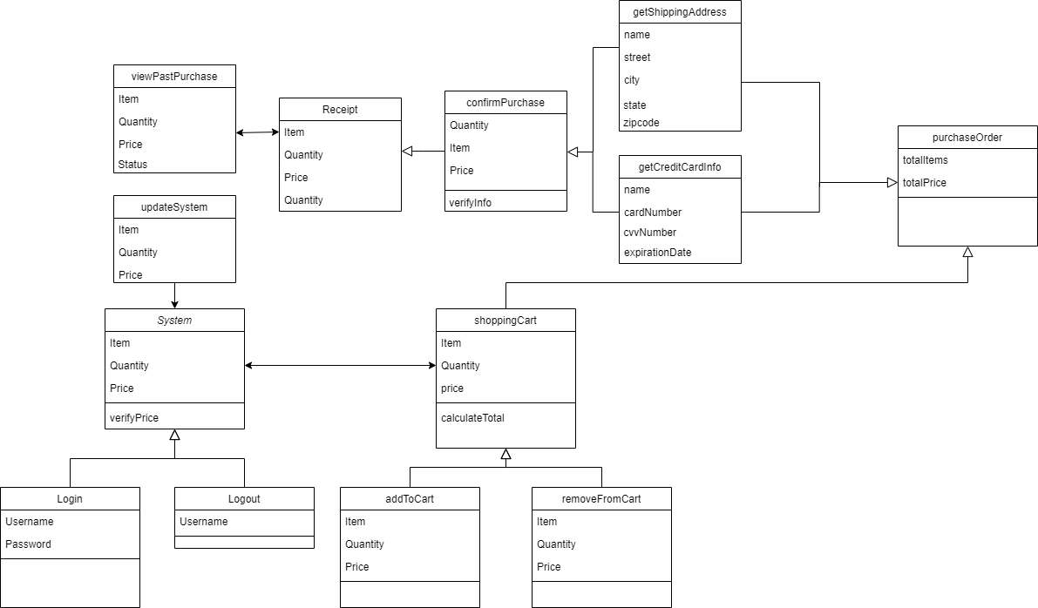
  + Discuss experiences and lessons learned
    - What did you learn (5pts)? How does this assignment compare with other academic assignments or professional experience (3pts)?
    - What are the benefits to the upfront design process (4 pts)? Did the upfront design in Assignment 2 help in assigning coding tasks? How? (4 pts)
    - How familiar are you with Git/Github? (4 pts)